**Introduction to Human Computer Interaction**

**Assignment No. 1**



**Submitted To**

Dr. Umar Qasim

**Submitted By**

Malik Moez Nawaz 2021-SE-30

Wali M. Ahmad 2021-SE-39

**Assignment Title**

Website Evaluation Based on Design Principles and Guidelines.

**Website Link**

[https://charcoal.com.pk](https://charcoal.com.pk/)

**[Department of Computer Science]**

**University of Engineering and Technology (New Campus),**

**Lahore.**

* **Organization Overview**

Charcoal menswear was founded in Pakistan in 2008 and is now one of the leading retailers of apparel and accessories for men from its beginning as a manufacturer of casual and formal clothing, charcoal has developed into one of the most leading brands in Pakistan.

Charcoal is a fast-growing company being engaged in the business of manufacturing, import and supply/sale of all type of clothing. All the products and services are designated and protected by trademark (Charcoal). The "Charcoal" is well known brand with a large customer base.

* **Website Structure**

Website contains following webpages:

1. **Homepage**
2. **Individual Categories page (New Arrivals, Collection, Accessories)**
3. **Product view page**
4. **About us page**
5. **Search product page**

* **Homepage**

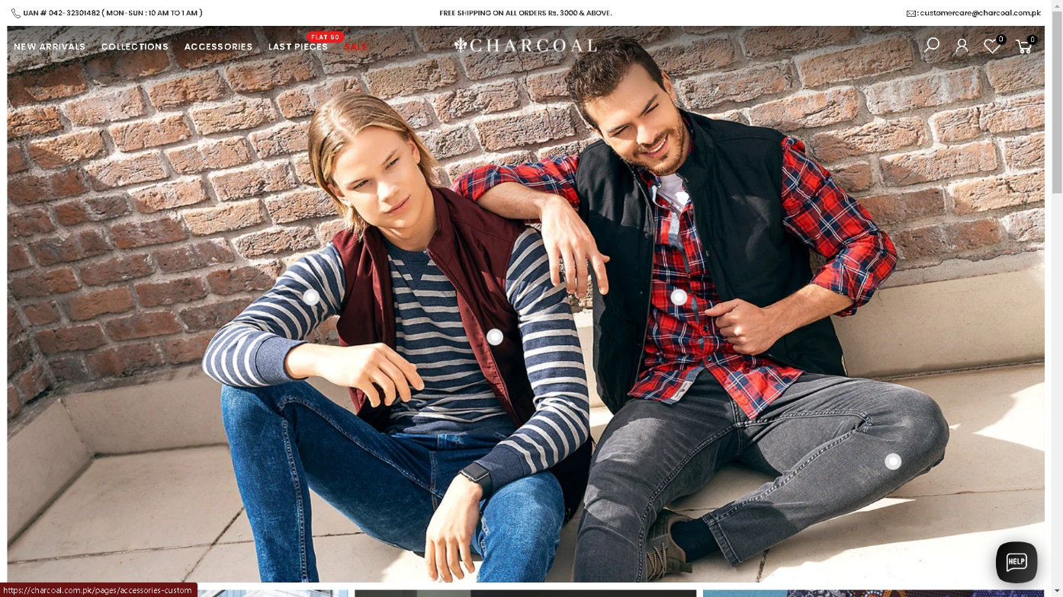

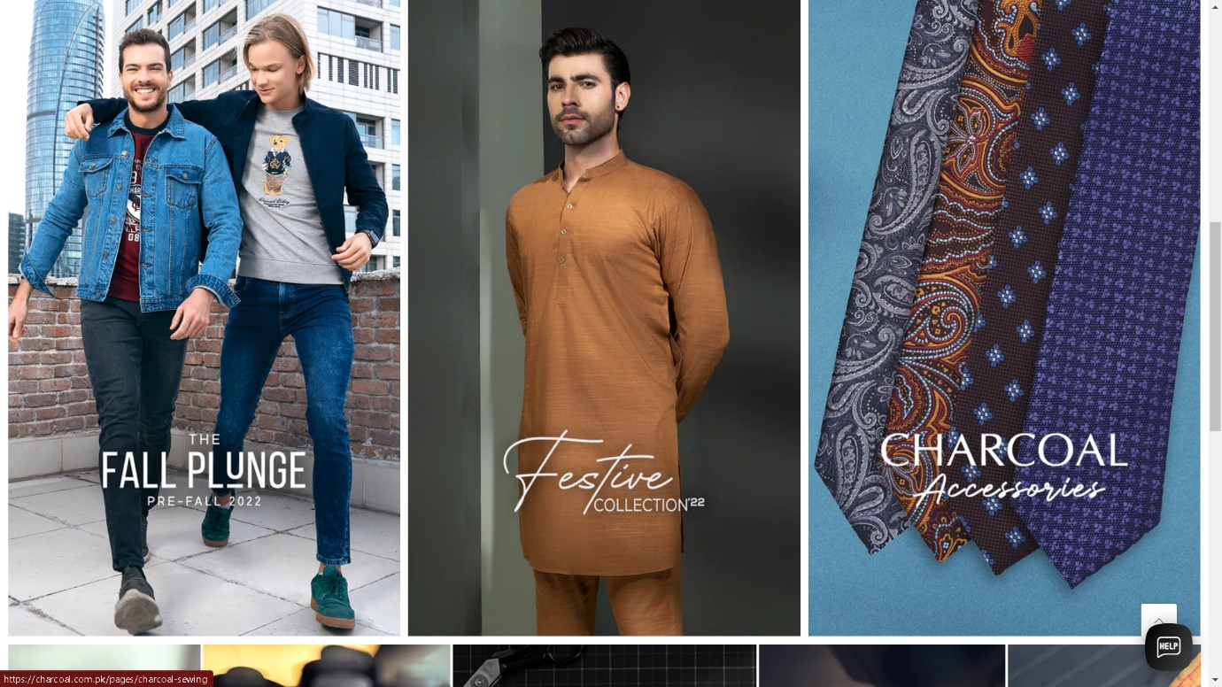

**Website Evaluation**

* **Visibility**
* **Website Logo**
* The Website Logo is not clearly visible. There is no distinction between the Background image link (**Homepage background**) and Website Logo.
* User might click on Background image link instead of Logo to jump to Homepage.
* There is no Feedback visible when clicked. However, cursor shape is changed when hover on Logo to indicate that it is a clickable link.

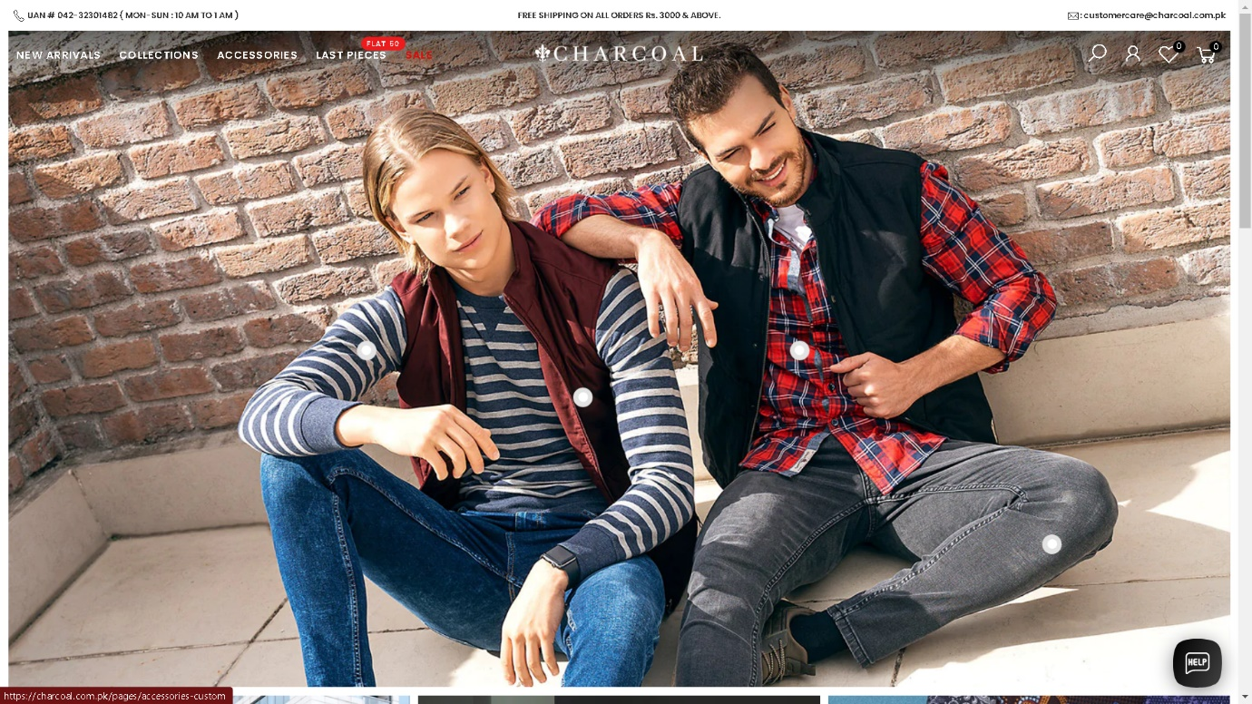

* **Feedback & Visible Effects**
* There is no Feedback visible when any of sub-category option is clicked.
* Buttons does not change state when sub-category option is clicked. Hence, no Feedback to user.
* A novice user can select any other option instead of selecting the right option.

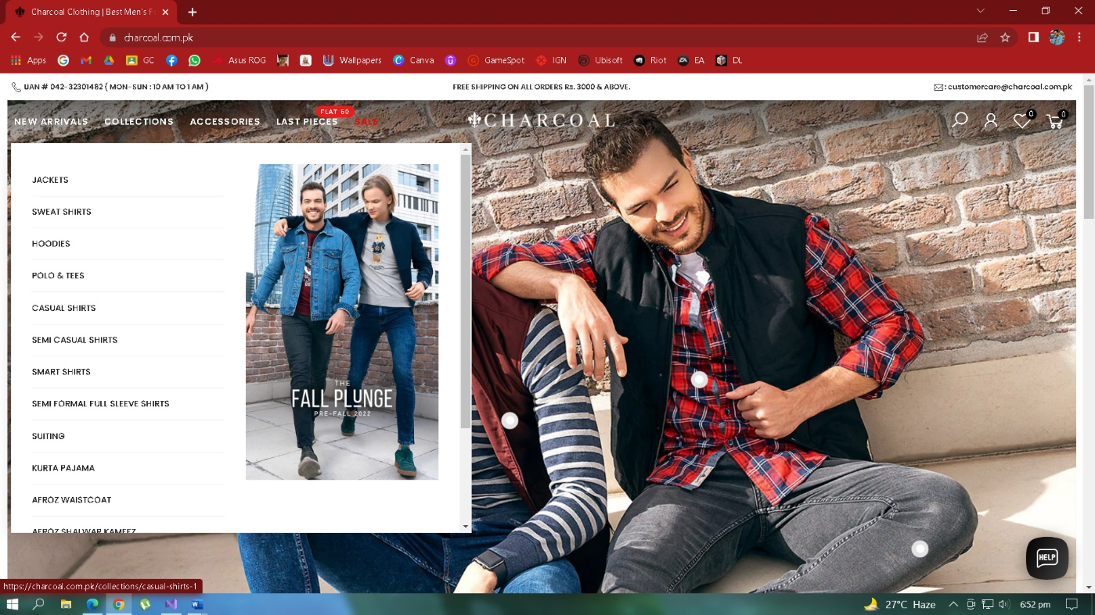

* **Pagination**
* There is no Pagination available on **Product buy, Categories (New Arrival, Collections, Accessories)** pages. Thus, User can’t Navigate through website pages.
* There is a ‘Load More’ button available at the end of Products, but there is no control to User to directly navigate such as in Pagination where page numbers were available.

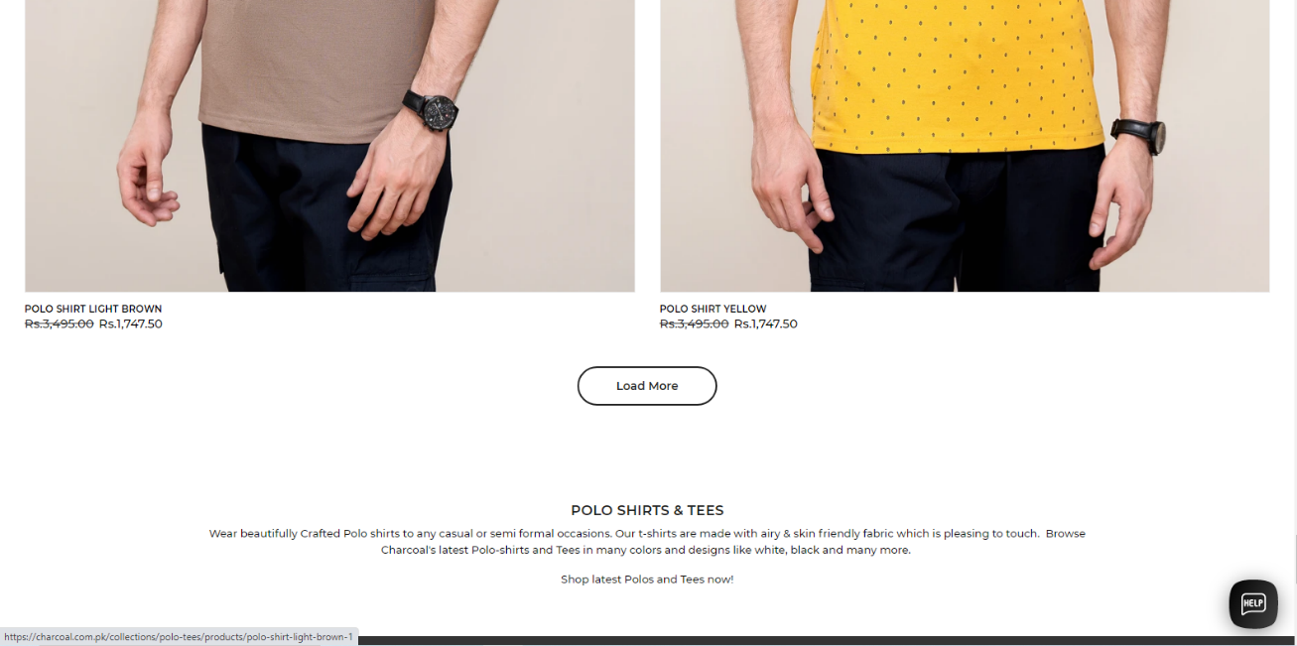

* On Sales Page and Limited search pages, there is no “Load More” Button or pagination available because the end of products.

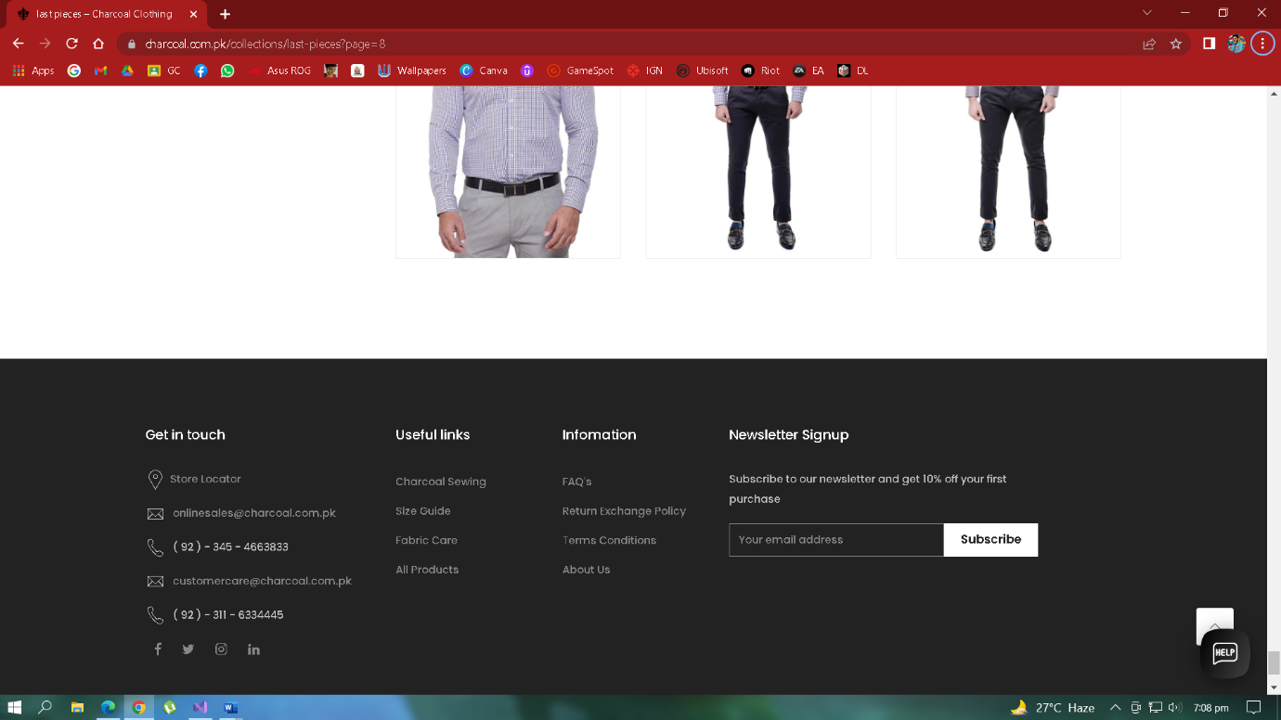

* **Product Images**
* Extensively large product images are shown in Categories menu (**New Arrival, Collection & SALE etc.**) which does not provide clear visibility of other products available. Hence, blocks User view to see multiple products.
* Small images of products from front and back should be used, so User gets a clear view of a product from both sides on a single page.

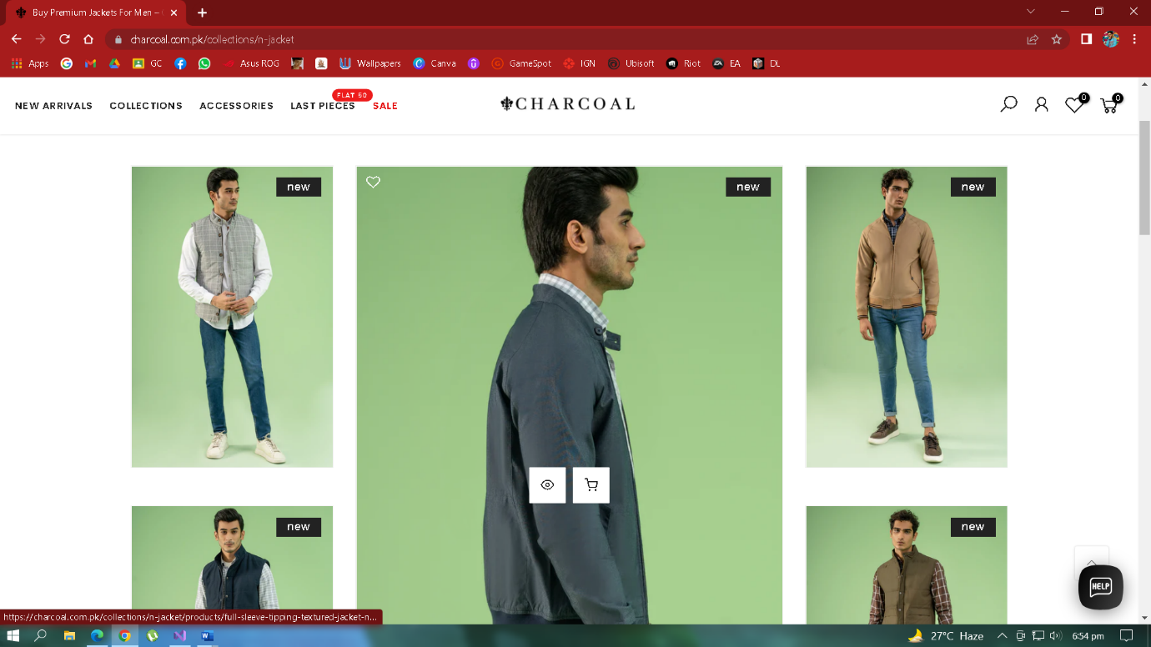

* **Search Bar**
* There is no proper Search Bar available. Hence, User first have to click on Search icon and then Search option will be there. Thus, limits User visibility.
* When Search icon is clicked, there is no Filters, no Instant or Realtime results.
* There is no sub-level of search options like search by **Name**, search by **Category** etc.
* Search icon should be removed and there should be a proper Search bar with multiple Searching options like Filters, Categorized Search, etc. so User can properly Search products.

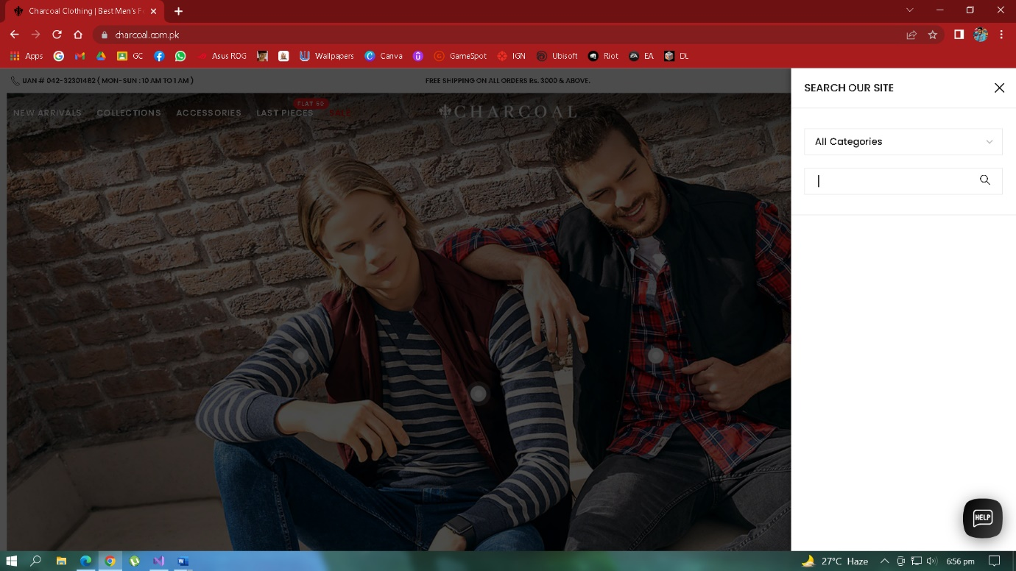

* **Simple and Natural Language**
* **Product Images**
* Extensively large product images were shown when browsing through products. Hence, blocks User view to see multiple products from front and back side of product in a single page.
* Small images of products should be used, so User gets a clear view of multiple products on a single page.

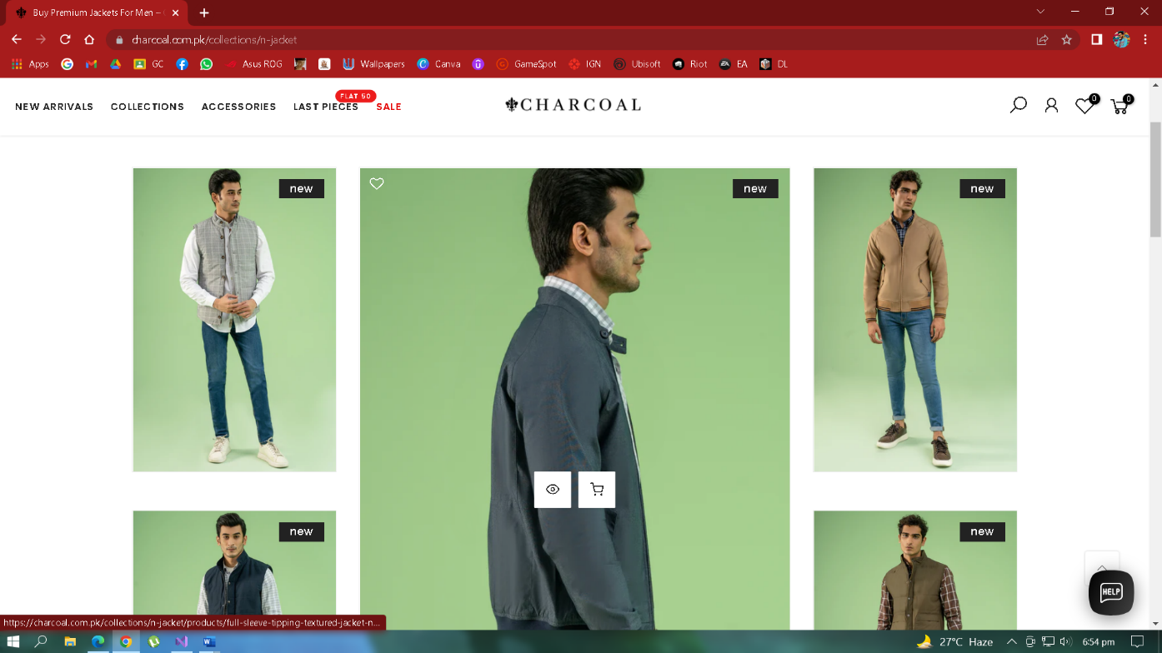

* **Product Details**
* Too much information and details about a product is shown when a product is clicked.
* Providing details like **Product Description, Product Care, Product Reviews** on a single page does not provide Simple and Clean Experience.
* Unnecessary information like **Stock left, Product Care, Product Reviews** should be removed so that User gets a Simple, Clean and Better Experience.

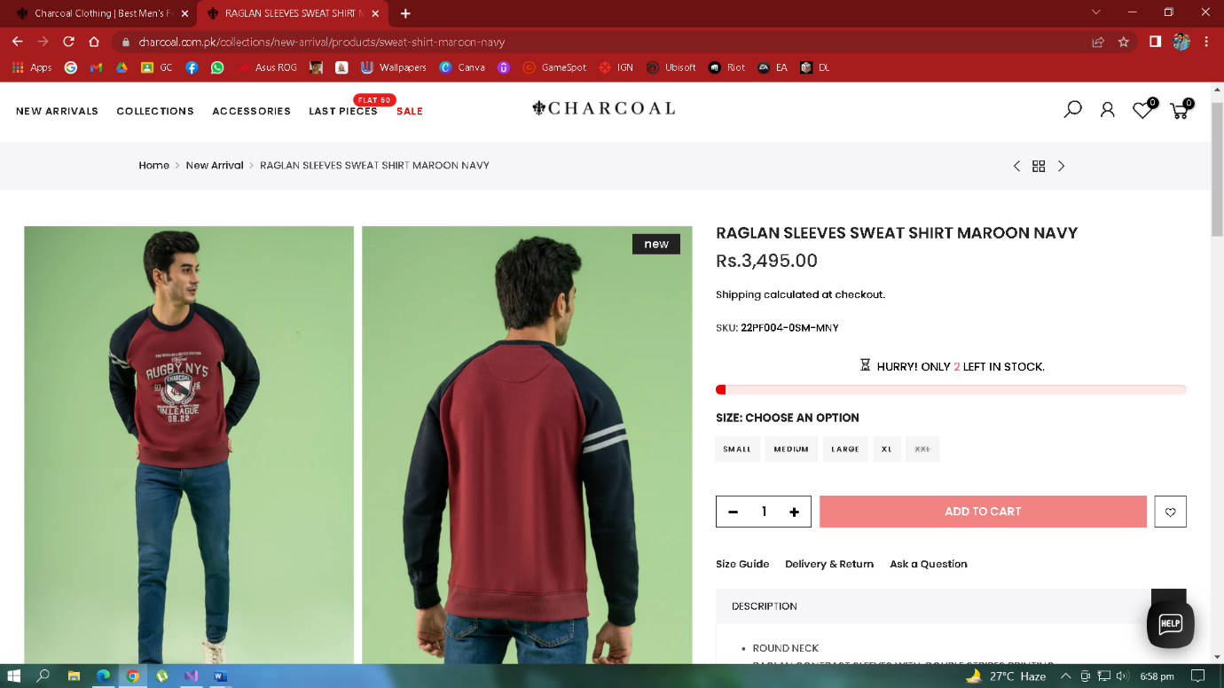

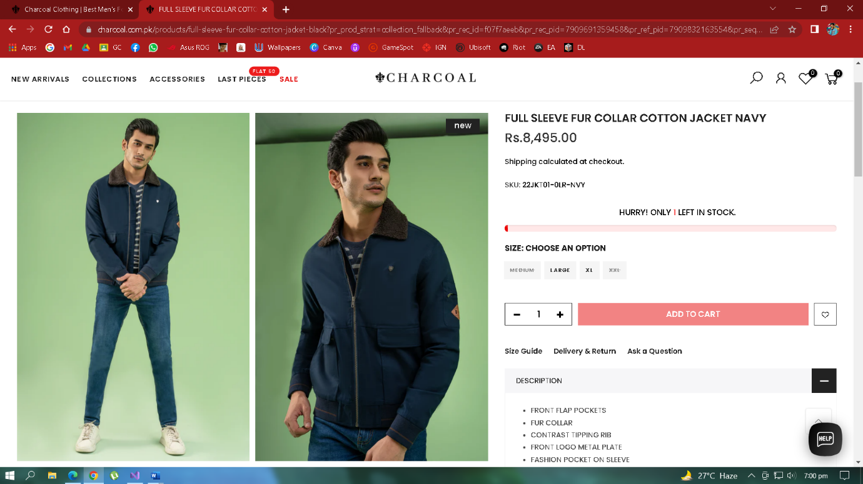

* **Delivery & Return of Products**
* When User wants to return a purchased product, the User first have to click on ‘**Delivery and Return**’ option and then read the Organization’s Terms and Conditions.
* When ‘**Delivery and Return**’ option clicked, Organization’s Terms and Conditions contains extensive and Domain-related terms, that a User doesn’t want.
* Simple and Intuitive process and terms should be used for ‘**Delivery and Return**’ of products.
* Simple language should be used in ‘**Delivery and Return**’ disclaimers so that a novice and illiterate user can also understand the disclaimer.

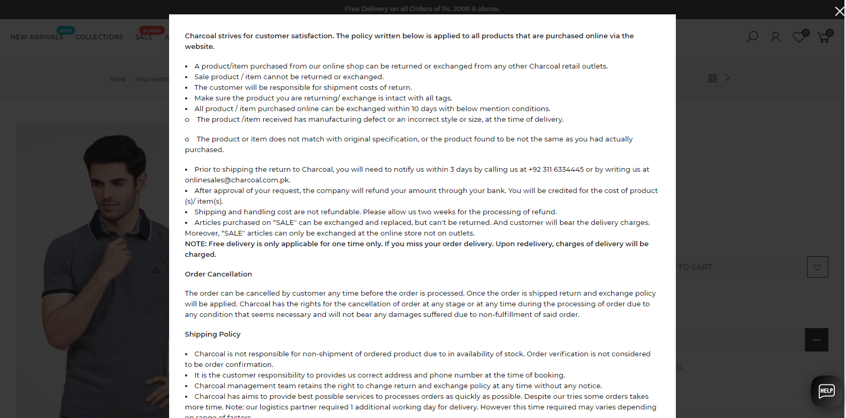

* **Website Footer**
* Website Footer contains **Technical**, **Domain-related**, **Business-related** options that a normal and regular User does not need.
* **Technical** options should be removed from Website Footer so that it should provide a Simple, Clean and Enhanced User Experience.
* Website Footer should be small in size because no user pay attention to website footer.

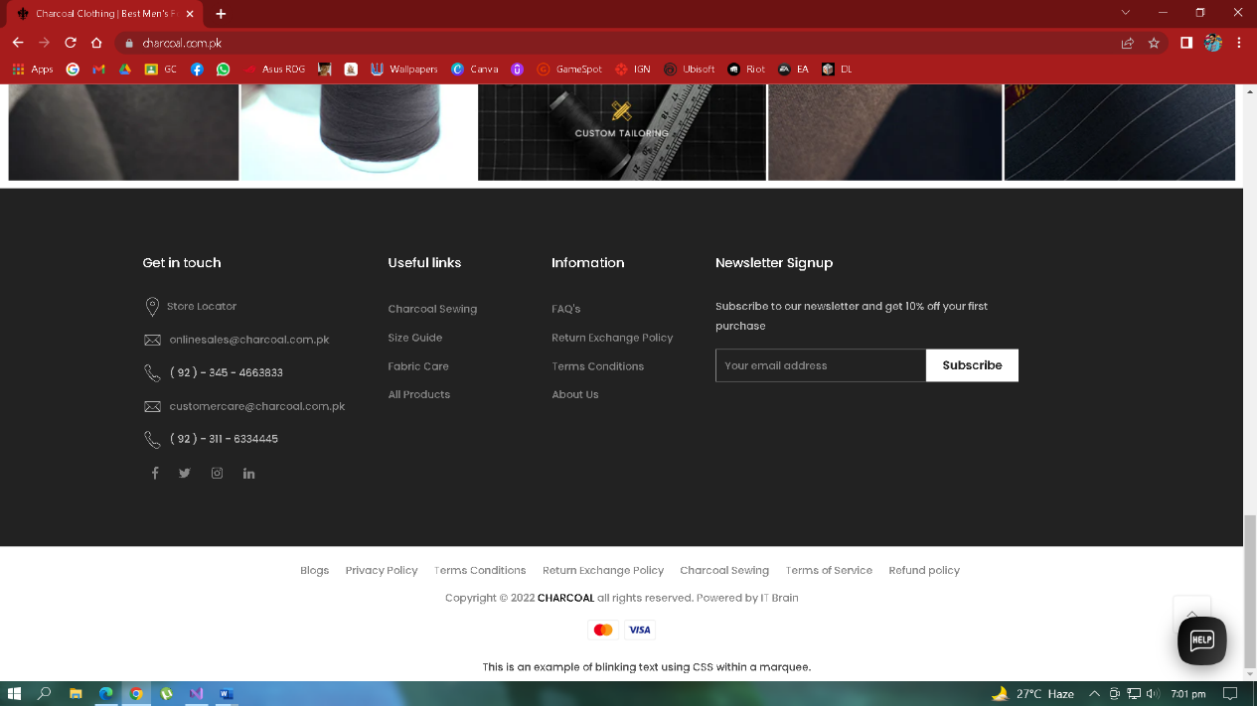

* **Minimize User’s Memory Load**
* **Return & Exchange Policy**
* ‘**Return & Exchange**’ policy terms and conditions were not simple, and not applicable to all products. So, it’s difficult for a User to remember those policy terms.
* Although it is necessary for a website to show their disclaimers and policy but mostly user do give attention and they don’t bother to read them. So, they should make their disclaimers and policy book short instead of showing them on whole page.
* **Return & Exchange**’ policy terms and conditions should be simple and limited so that a User can easily Understand, Remember, and a simple Process to be followed.
* If a user really wants to read their disclaimers and policy terms so a button should be given at the disclaimers and policy terms box so that the user and click on that button and can go on the disclaimers and policy page.

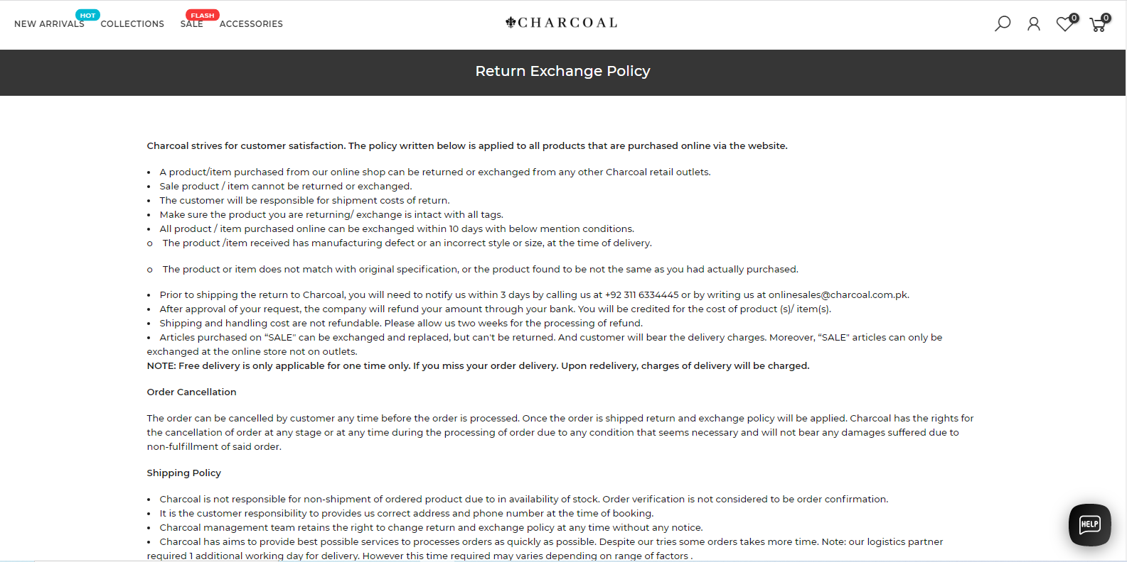

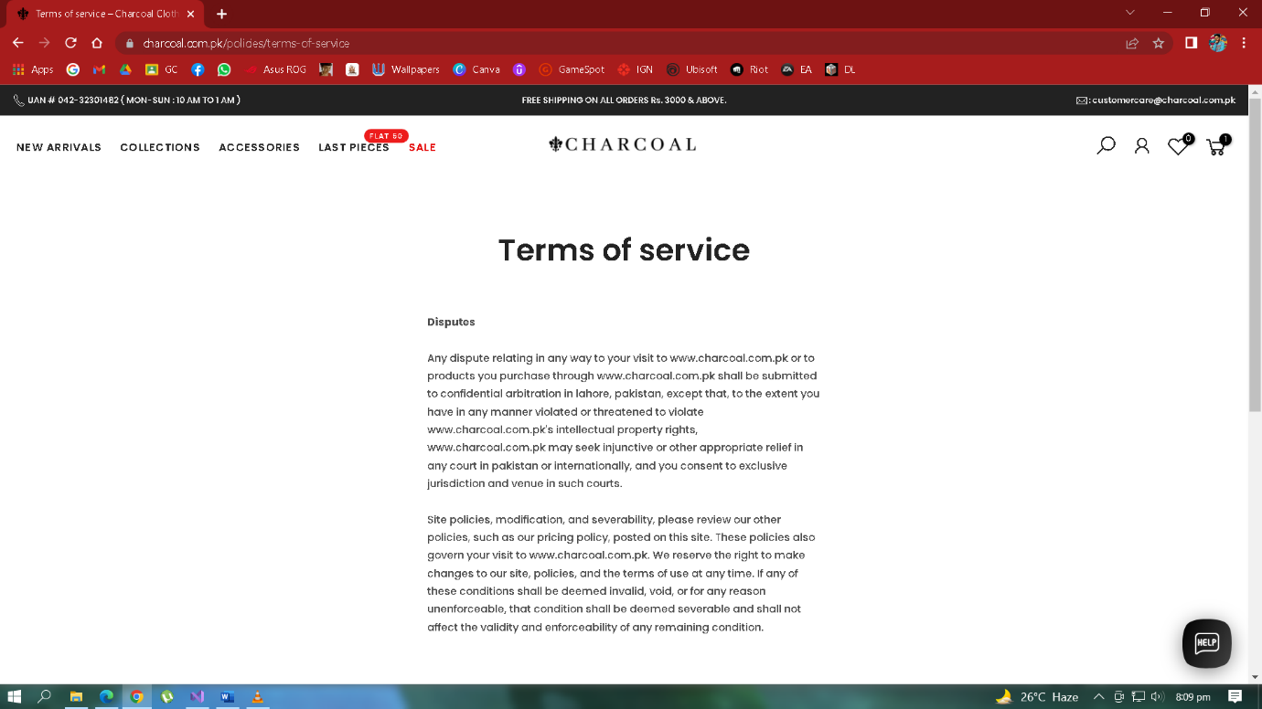

* **Consistency**
* **Product Categories & Menu**
* Consistency is present in whole Website E.g., all Product Categories and Menu options contains consistent Product images size, consistent Button size and colors, etc.
* All products information and details are shown in a consistent manner. There is no in-consistency during browsing of different products.

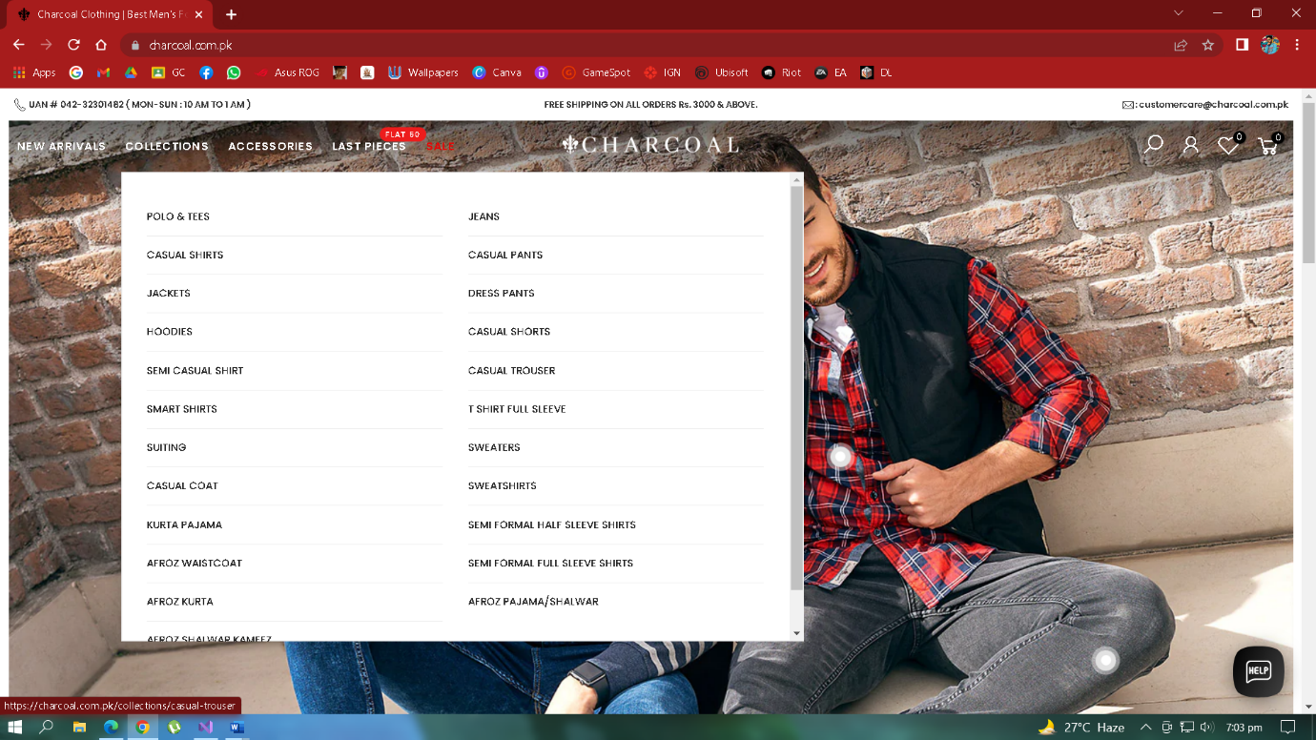

* **Website Structure**
* Website Header, Logo alignment and other options (New Arrivals, Collections & SALE) remains same at each page.
* Website Footer is also consistent and same during navigation of all Webpages. There is no change, and no in-consistency.
* Over-all Website is well-managed and consistent.



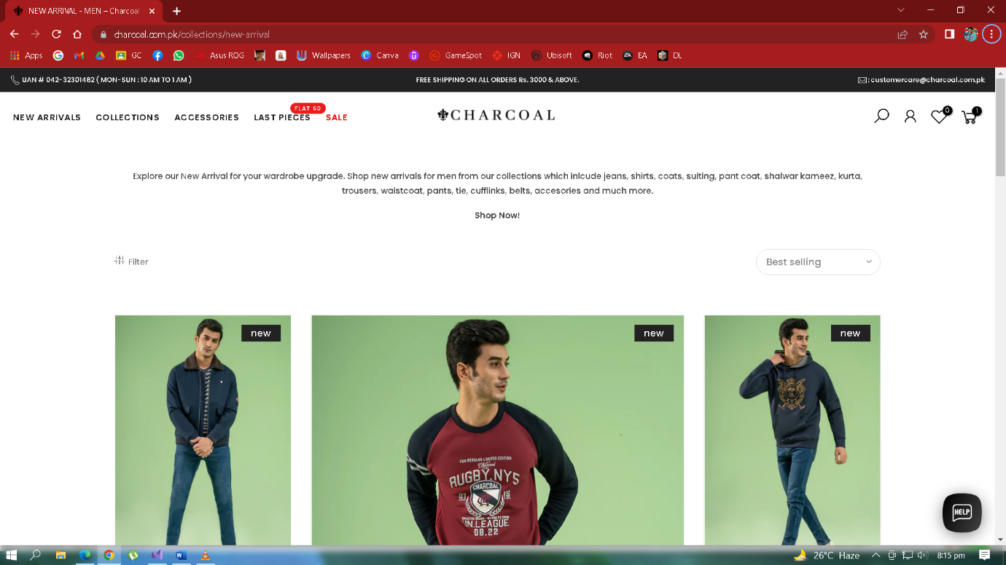

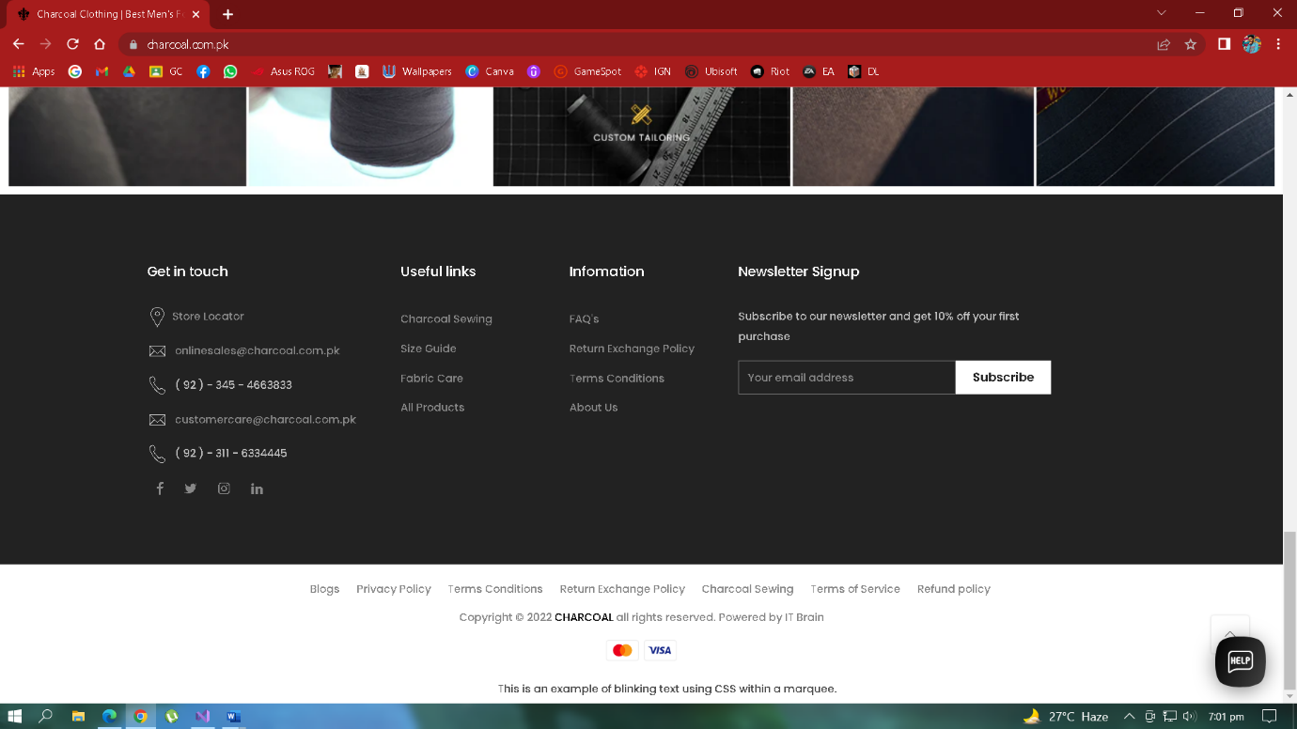

* **User Control & Freedom**
* **Help and Support**
* Dedicated Customer Help and Support button is available throughout the Website.
* Other most commonly used Communication Webapps and platforms like **Facebook**, and **WhatsApp** were also available for Customer support.

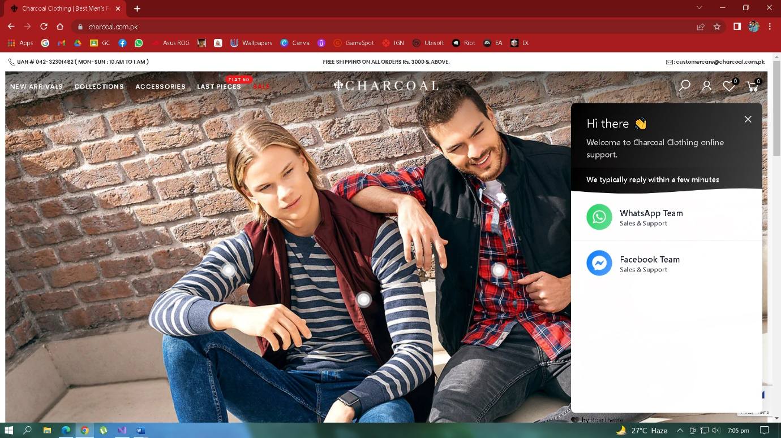

* **Browse Products**
* There is a ‘Load More’ button available at the end of Products, but there is no control to User to directly navigate such as in Pagination where page numbers were available.
* No breadcrumbs available. Hence, User can’t go back to previous Webpages.



* **Support Undo**
* **Remove Products**
* Products can be removed easily from **Cart** option.
* Product quantity can be increased or decreased easily with the help of button available.
* Products can be added and removed to ‘**My Favorite**’ category through dedicated button.

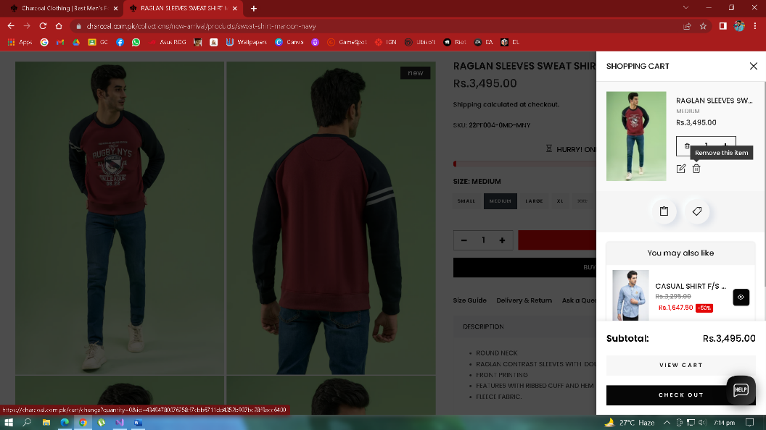

* **Shortcuts**
* **Product Categories & Menu**
* Different Product Categories and Menus are available on all Webpages to browse and view different products easily.
* Products are sorted according to their Categories and provide ease to quickly look and find products.
* **Items Cart**
* All purchased and wish-listed products can be viewed on item **Cart** option available on all Webpages.
* Products can be added, removed and proceed to checkout procedure through the item Cart.

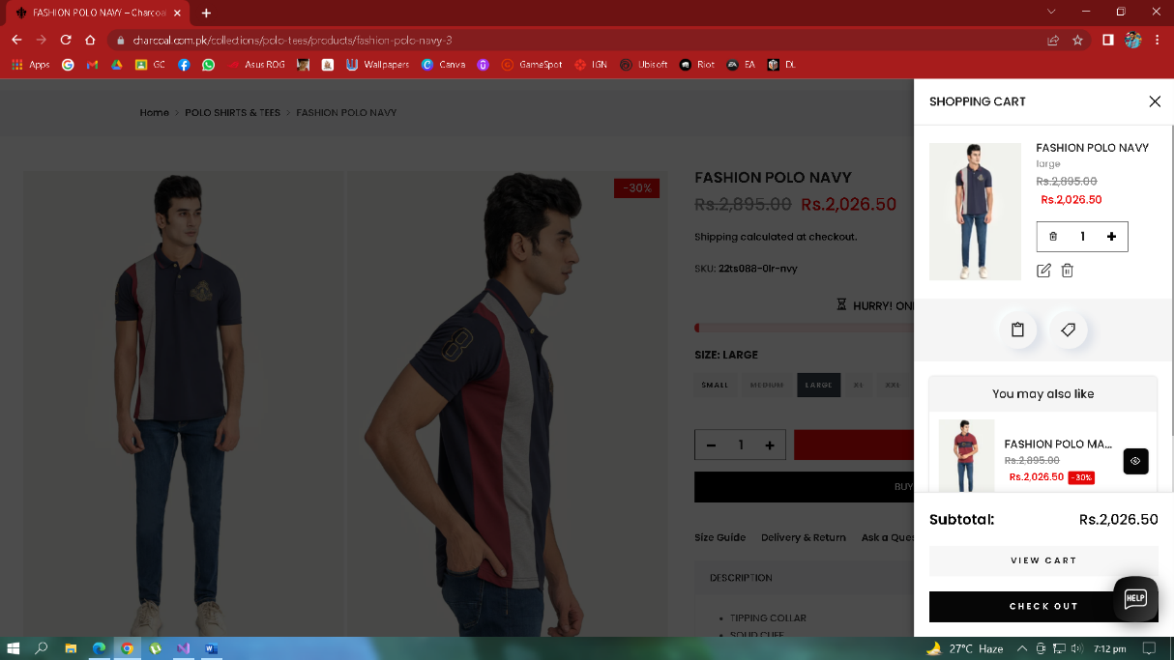

* **Deal with Errors**
* **Remove Products**
* There are no Confirmation messages shown, Products can be removed from **Cart** option directly.
* Product quantity can be increased or decreased directly with the help of button available but there should be confirmation to avoid accidental changes and mistakes being made.

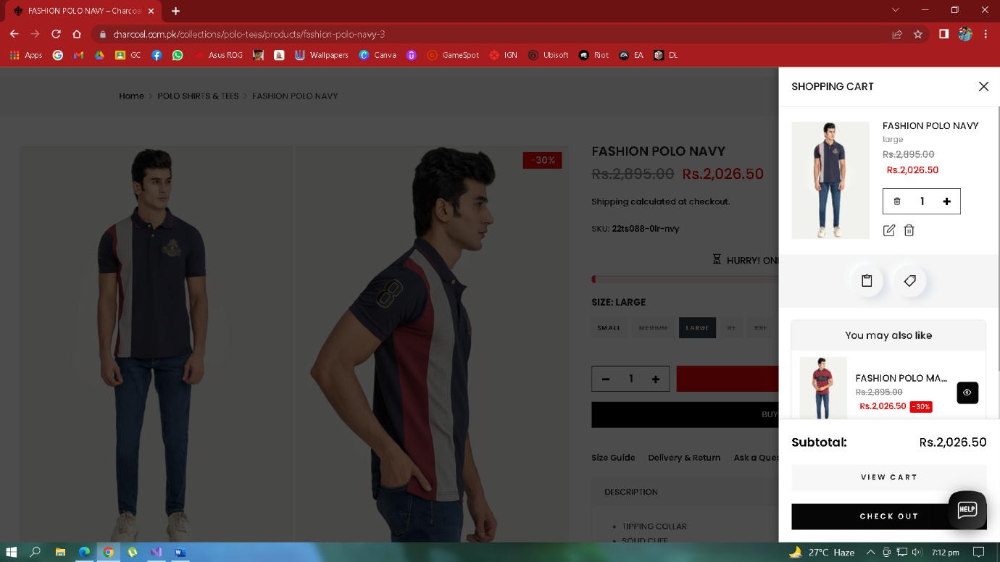

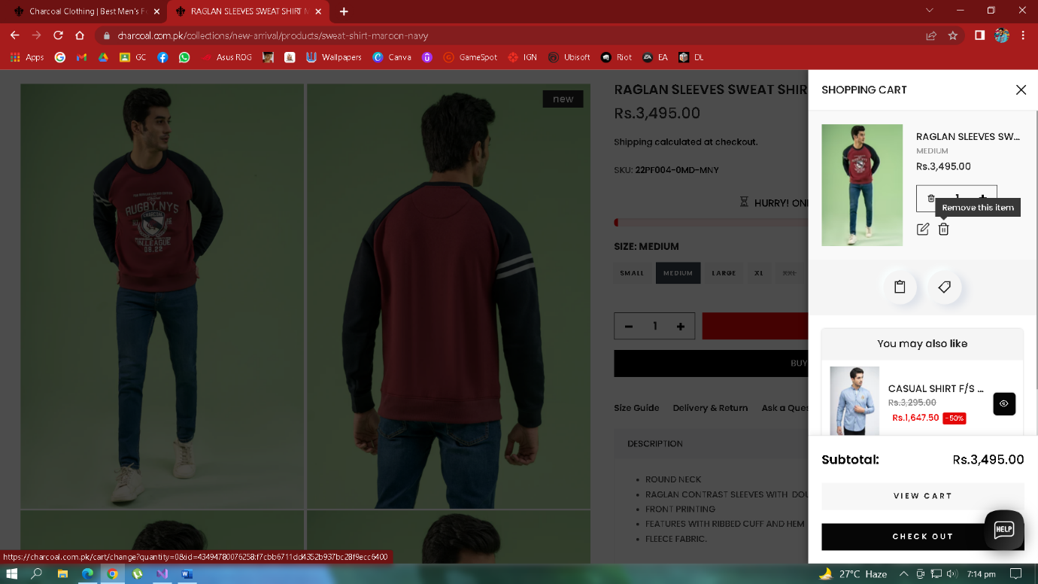

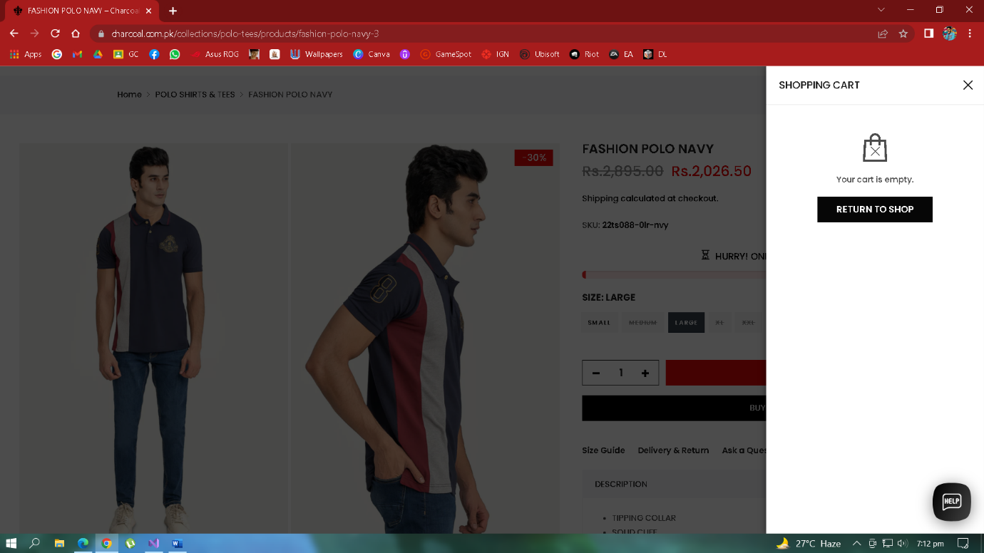

* **FAQ**
* There is an Option of FAQ is given at the footer of website so that if you user got stuck in an error, he/she can read the FAQs and Solve the problem.

